Title

Nguyen Van A1*, Tran Văn B2, ...

1address 1;

2address 2.

……….

*Corresponding author: [example@gmail.com](mailto:example@gmail.com).

Received ; Revised ; Accepted.

**DOI:**

**ABSTRACT**

*About 200 words, state the purpose, content, methods and achieved results.*

**Keywords:** no more than 6 keywords.

1. INTRODUCTION

- Referring to previous research results about the problem to be researched [1, 2].

- Analyze the advantages, disadvantages of the previous research results [5-10].

- State the reason for the problem to be studied: new theories, supplementing theories, clarifying theories, improving methods, technology improvements, applications,...

- Specify the problem to be solved according to the structure of the article: section 2, section 3,...

2. PROBLEM

2.1. Theoretical foundations

Present the specific content here, if there is a subsection, it will be presented as follows

2.1.1. Assumption

2.1.2. Formulas

|  |  |
| --- | --- |
|  | (1) |

Where,  is ...,  are ... respectively.

Note: Formulas are typed in Mathtype or equation in Word. In particular, do not leave the formula as an image. Numberring formulas from (1) to (n), DO NOT number as (2.1), (2.2), (3.1), (3.2).

2.2. Experiment preparation

2.2.1. Instrumentation

2.2.2. Experimental materials

The temperature measurement results that change with the time of day are presented in table 1.

**Table 1.** Ambient temperature changes by hour of day.

|  |  |  |  |  |  |  |  |
| --- | --- | --- | --- | --- | --- | --- | --- |
| **Hour of the day (h)** |  |  |  |  |  |  |  |
| **Temperature**  **(oC)** |  |  |  |  |  |  |  |

Note: You can change the font size so that the table fits inside the template.

The change of humidity with temperature is shown in figure 1. Figure and figure caption are centered.

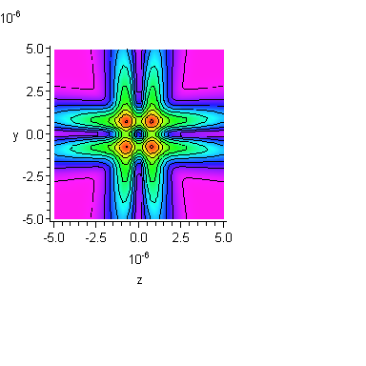

**Figure 1.** Name of the figure.

Note: The image must be inserted with a .jpg file with high resolution. Figure must be drawn by Origin software, NOT drawn by Excel.

3. (RESULTS AND DISCUSTION)

3.1. Input data

3.2. Methods, simulation tools

3.3. Simulation results and comments

- What do the results show?

- Consistent with theory, reality?

- What is different from previous works?

- Practical benefits?

- ...

4. (CONCLUSION)

Based on theories, methods, using materials, what results have been found.

The outcome is new, to some extent, or equivalent to the other results.

This result can be applied in any field.

What other issues need further consideration?

Where is the development direction of the research problem, can it be further developed or not.

**Acknowledgement:**

REFERENCES

1. H.N.S. Krishnamoorthy, Z. Jacob, E. Narimanov, I. Kretzschmar, V.M. Menon, Science 336 (2012) 205.
2. A. T. Landau *et al*, “ *Title of the cited article*,” J. of electromganetic,**Vol. 12**, No. 3 (1998), pp. 44-65.
3. H. V. Anh, “*Tên sách*,” NXB Khoa học Kỹ thuật (2005), tr. 11-23.
4. B. C. Danh, “*Title of the cited article*,” Proc. of 5th National Symposium… on Chemical Science, Date, City (2001), pp. 36-40.

TÓM TẮT

**Tên bài báo**

Khoảng 200 từ , nêu bật mục đích, nội dung, phương pháp và kết quả đạt được (about 200 words).

**Từ khoá:** Từ khoá 1; Từ khoá 2; Từ khoá 2.